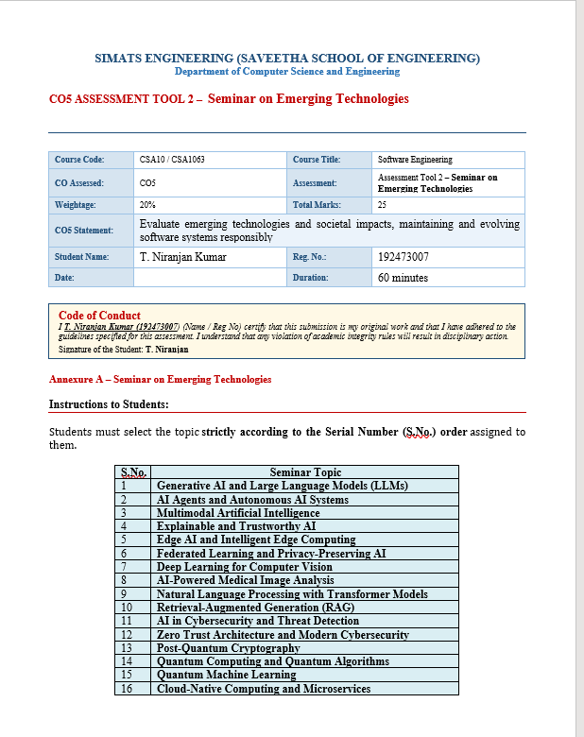

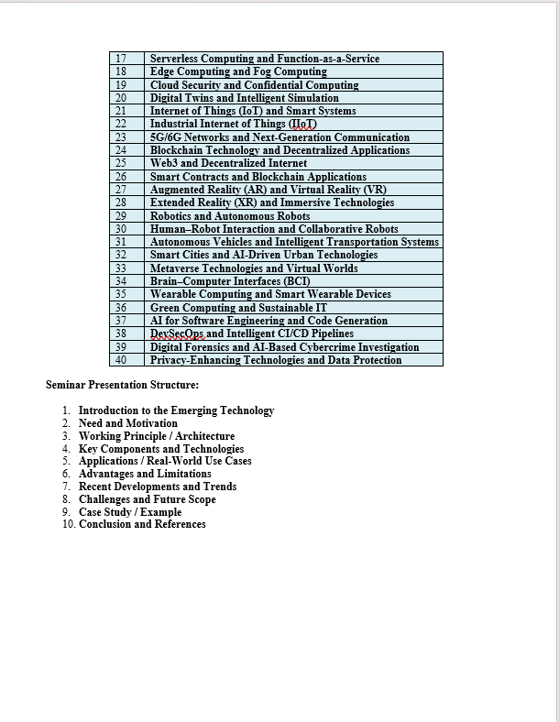
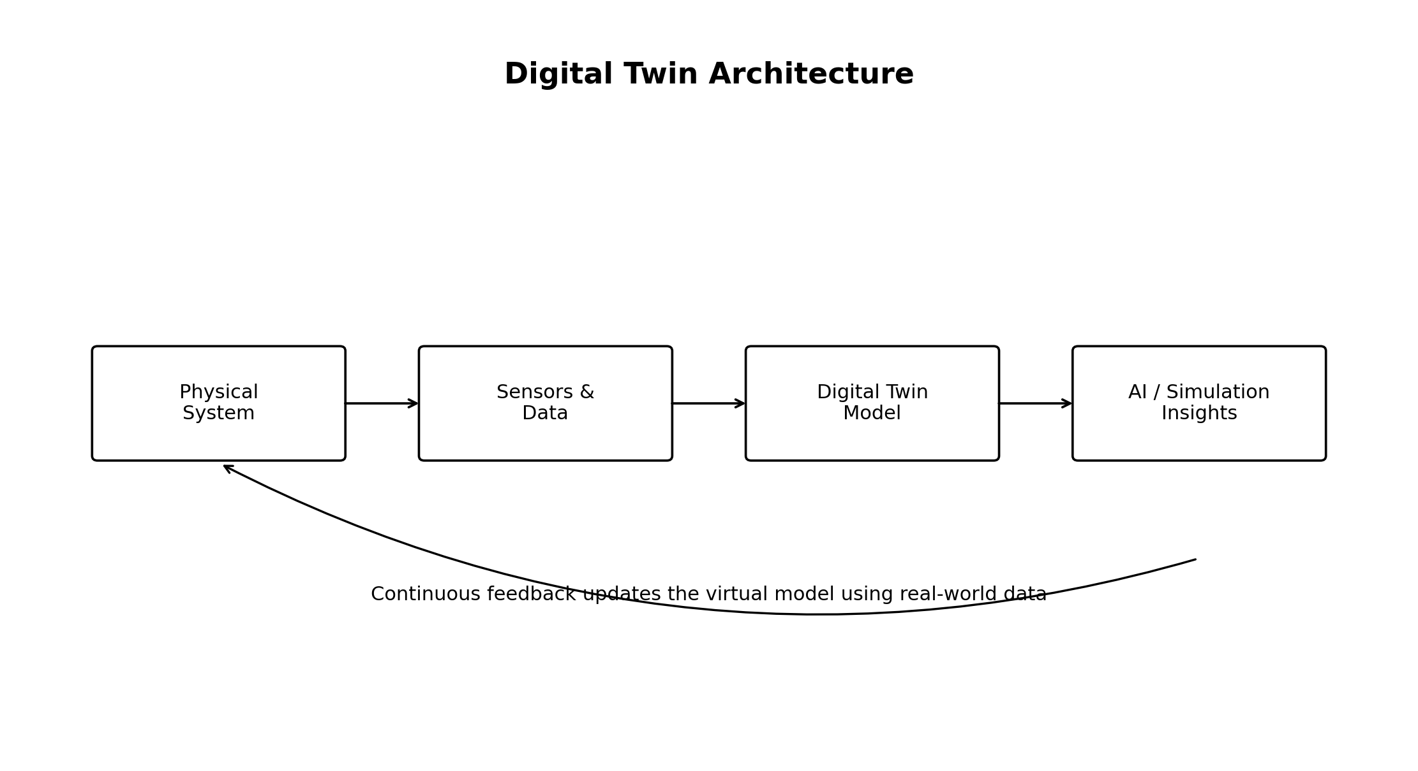

1. Introduction to Digital Twins and Intelligent Simulation
A Digital Twin is a dynamic virtual representation of a physical object, system, process, or environment. It receives data from the real system, updates its digital model, and helps users observe, analyse, predict, and optimize real-world behaviour. Intelligent Simulation extends this idea by combining simulation models with Artificial Intelligence (AI), Machine Learning (ML), analytics, and real-time data.
Unlike a traditional static simulation, an intelligent digital twin continuously evolves as new data is received. This makes it useful for monitoring complex systems, testing 'what-if' scenarios, detecting anomalies, predicting failures, and supporting better decisions before changes are applied to the real system.

2. Need and Motivation
- Real-world systems such as factories, vehicles, buildings, and cities are complex and expensive to test physically.
- Failures can cause high maintenance cost, downtime, safety risks, and resource wastage.
- Organizations need real-time visibility into the condition and performance of important systems.
- Simulation allows engineers to test multiple scenarios without disturbing the physical system.
- AI can improve prediction, anomaly detection, optimization, and automated decision support.
- Digital twins support responsible and sustainable system evolution by reducing unnecessary physical trials and resource consumption.

3. Working Principle / Architecture
The basic architecture contains a physical system, sensors or data sources, communication and storage, a virtual digital model, simulation/analytics components, and a feedback mechanism. Data flows from the physical system to the digital twin, where the model is updated and analysed. The resulting predictions or optimization recommendations can then be used to support actions in the real system.


4. Key Components and Technologies
Component | Role | Examples / Technologies
Physical Entity | The real machine, process, product, building, vehicle, or system being represented. | Industrial machines, vehicles, turbines
Sensors & IoT | Collect real-time data such as temperature, pressure, location, vibration, and usage. | IoT sensors, RFID, embedded devices
Connectivity | Transfers data between the physical and digital environments. | 5G/6G, Wi-Fi, MQTT, edge networks
Data Platform | Stores, processes, and manages historical and streaming data. | Cloud platforms, databases, data lakes
Digital Model | Virtual representation that captures the structure and behaviour of the real system. | Physics models, 3D models, system models
Simulation Engine | Runs experiments and what-if scenarios in the virtual environment. | Discrete-event, agent-based, numerical simulation
AI / ML | Learns patterns, predicts future behaviour, and supports optimization. | Predictive analytics, anomaly detection, deep learning
Visualization | Provides dashboards and interactive views for users. | Dashboards, 3D visualization, AR/VR

5. Applications / Real-World Use Cases
Application Area | Digital Twin Use
Manufacturing | Monitor production lines, predict machine failures, optimize maintenance and energy usage.
Healthcare | Create patient or device models for treatment planning, monitoring, and simulation.
Smart Cities | Simulate traffic, energy, water, infrastructure, and emergency-response scenarios.
Automotive | Test vehicle performance, battery behaviour, and predictive maintenance models.
Aerospace | Monitor aircraft or engine condition and analyse maintenance requirements.
Energy | Optimize wind farms, power grids, turbines, and energy consumption.
Buildings | Analyse occupancy, HVAC behaviour, energy efficiency, and maintenance.
Software Systems | Model complex system behaviour, test changes, and support performance or reliability analysis.

6. Advantages and Limitations
Advantages | Limitations
Real-time monitoring and better visibility | High initial cost for sensors, models, and infrastructure
Predictive maintenance and reduced downtime | Data quality problems can produce inaccurate predictions
Safe testing through what-if simulation | Complex systems may require difficult and expensive modelling
Improved optimization and decision support | Cybersecurity and privacy risks must be managed
Reduced physical prototyping and resource waste | Integration across different vendors and platforms can be challenging
Supports continuous improvement of systems | Requires skilled teams in IoT, data, simulation, and AI

7. Recent Developments and Trends
- AI-enhanced digital twins that combine physical models with machine-learning predictions.
- Hybrid twins that combine physics-based simulation and data-driven models.
- Edge AI and edge computing for faster local processing and reduced cloud latency.
- Integration with 5G/6G and Industrial IoT for low-latency communication.
- Use of Generative AI and large language models to assist engineers with analysis, documentation, and interaction.
- Immersive visualization through AR/VR and extended reality interfaces.
- Federated and privacy-preserving approaches for sensitive distributed data.
- Greater focus on interoperability, open standards, cybersecurity, sustainability, and trustworthy AI.

8. Challenges and Future Scope
Major challenges include interoperability, accurate synchronization between physical and virtual systems, data quality, model validation, cybersecurity, privacy, scalability, and the cost of deployment.
Challenge | Future Direction
Data Quality | Use data validation, sensor fusion, and AI-based anomaly filtering.
Model Accuracy | Develop hybrid models combining domain knowledge and machine learning.
Scalability | Use cloud-edge architectures and distributed simulation.
Interoperability | Adopt open standards and common digital-twin frameworks.
Cybersecurity | Apply Zero Trust, encryption, identity management, and continuous monitoring.
Human Interaction | Improve explainability and immersive AR/VR-based visualization.
Sustainability | Use twins to optimize energy, materials, maintenance, and carbon impact.

9. Case Study / Example: Predictive Maintenance in a Smart Factory
Consider a factory containing a critical motor. Sensors continuously collect vibration, temperature, speed, and operating-hour data. The data is sent to the digital twin, where a virtual model represents the motor's expected behaviour. Intelligent simulation and machine-learning models compare expected and actual behaviour. If abnormal vibration patterns indicate a possible bearing failure, the system can estimate the risk and recommend maintenance before a complete breakdown occurs.
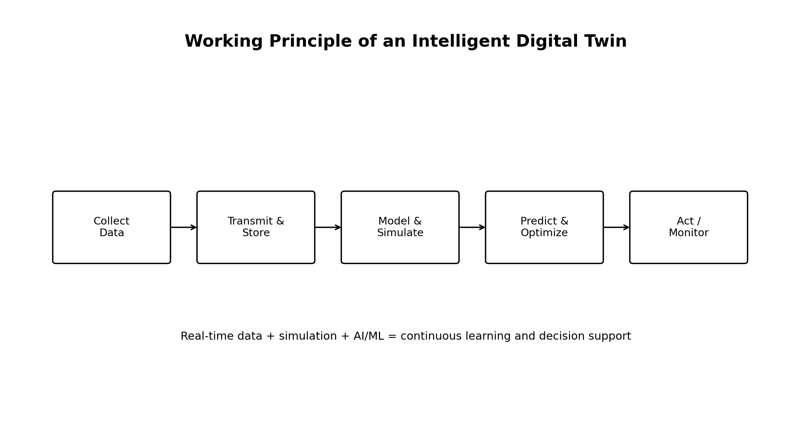
Figure 2. Intelligent Digital Twin Workflow for Predictive Maintenance
Step | Activity | Outcome
1 | Sensors collect real-time motor data | Continuous monitoring
2 | Data is transmitted to the digital twin | Updated virtual state
3 | Simulation compares expected and actual behaviour | Abnormal behaviour identified
4 | AI predicts failure risk | Early warning
5 | Maintenance is scheduled before failure | Reduced downtime and cost

10. Conclusion
Digital Twins and Intelligent Simulation represent an important emerging technology because they connect real-world systems with continuously updated virtual models. By combining IoT, cloud/edge computing, simulation, AI, and analytics, digital twins can improve monitoring, prediction, optimization, and responsible system evolution. Their future potential is significant across manufacturing, healthcare, smart cities, energy, transportation, and software systems. However, successful adoption requires careful attention to data quality, interoperability, cybersecurity, privacy, scalability, and model accuracy.

11. Important Seminar Viva Questions and Answers
Question | Short Answer
What is a Digital Twin? | A Digital Twin is a dynamic virtual representation of a physical object, process, or system that is updated using real-world data.
What is the main difference between simulation and a Digital Twin? | A traditional simulation can be static or offline, while a Digital Twin is usually connected to real data and continuously updated.
Why is AI used in Digital Twins? | AI helps predict failures, detect anomalies, recognize patterns, optimize operations, and support intelligent decisions.
What technologies are used? | IoT sensors, cloud/edge computing, databases, simulation engines, AI/ML, communication networks, and visualization tools.
What is Intelligent Simulation? | It combines simulation with AI, real-time data, analytics, and optimization to make simulations adaptive and decision-oriented.
Give one real-world example. | Predictive maintenance in a smart factory, where sensor data and a digital twin predict machine failure before breakdown.
What are the major challenges? | Data quality, model accuracy, interoperability, cybersecurity, privacy, scalability, and deployment cost.
How does this support sustainability? | It reduces unnecessary physical testing, improves energy efficiency, optimizes maintenance, and reduces waste.

References
- M. Grieves and J. Vickers, “Digital Twin: Mitigating Unpredictable, Undesirable Emergent Behavior in Complex Systems,” in Transdisciplinary Perspectives on Complex Systems, 2017.
- E. Glaessgen and D. Stargel, “The Digital Twin Paradigm for Future NASA and U.S. Air Force Vehicles,” AIAA, 2012.
- A. Fuller, Z. Fan, C. Day, and C. Barlow, “Digital Twin: Enabling Technologies, Challenges and Open Research,” IEEE Access, vol. 8, 2020.
- F. Tao, H. Zhang, A. Liu, and A. Nee, “Digital Twin in Industry: State-of-the-Art,” IEEE Transactions on Industrial Informatics, 2019.
- ISO 23247, Automation Systems and Integration — Digital Twin Framework for Manufacturing, International Organization for Standardization.

